**NETWORKING PRINCIPLES LAB MANUAL 2**

**Lab Instructions:**

1. Attendance at all labs is mandatory.
2. Sharing of “check-in code” or checking without attending the lab is strictly prohibited.
3. Adhere to both the instructions provided in the lab manual and those given by the instructor.
4. Seek assistance from your instructor if you require help or clarification.
5. All students need to present their answers to the lab instructor before the end of the lab.
6. Students are required to present the earned badge for [“Getting Started with Cisco Packet Tracer”](https://skillsforall.com/course/getting-started-cisco-packet-tracer?utm_source=netacad.com&utm_medium=referral&utm_campaign=packet-tracer&courseLang=en-US&userlogin=0) to their instructor before commencing the lab.
7. Students are encouraged to collaborate in groups of three.

# Lab 2 – Part A - Packet Tracer–Deploy Devices

**Objectives**

❖ In this activity, you will deploy multiple devices.

**Required Resources**

• Latest version of Packet Tracer

## Instructions

A list of device labels is visible in the workspace. We will use various methods to deploy the listed devices.

**Note:** If you require more help with Packet Tracer, navigate to **Help > Contents** within Packet Tracer.

## Part A.1: Deploying the Devices

1. Locate the 2911 router in the **Device-Specific Selection Box**.
2. Using your mouse, drag and drop the 2911 router above the **Router0** label in the workspace.
3. Another way to deploy a device is to click the desired device and then click the desired location on the workspace. Click the 1941 router in the **Device-Specific Selection Box** and then click the space above the label **Router1** in the workspace.
4. Use either of the methods to put a 4331 router on the workspace over the **Router2** label.

## Part A.2: Deploying the Same Type of Devices Multiple Times

If you want to put multiple devices of the same type onto the workspace, the clicking and dragging can become very tedious. To avoid this, you can hold down the <CTRL> key as you click on the devices in the Device-Specific Selection Box.

1. Hold down the <CTRL> key and click the 4321 router in the **Device-Specific Selection Box**.
2. Now click the space above the labels **Router3**, **Router4**, and **Router5**.
3. To cancel the operation, click the **Cancel** icon where the 4321 router was in the **Device-Specific Selection Box**.

## Part A.3: Copying the Devices

The user can also copy devices on the workspace in two ways.

**Method #1**: Drag your cursor over the devices that you want to copy.

1. Drag a box over **Router3**. It should appear faded.
2. Hold down the <CTRL> key and drag **Router3** over the label **Copy of Router3**.
3. Repeat this with **Router4** and **Router5**.

**Method #2: Hold down the <SHIFT> key and click the devices to be copied.**

1. Selecting **Router1** and **Router2** while holding down the <SHIFT> key will again have a faded look.
2. Hold down the <CTRL> key and drag the devices to the space over the label **Copy of Router1** and release.

# Lab 2 – Part B - Packet Tracer–Deploy and Cable Devices

**Objectives**

❖ Deploy and Cable Network Devices.

**Background / Scenario**

You will locate, deploy, and cable multiple types of devices.

## Instructions Part B.1: Deploy the Devices

1. Navigate to the **Device-Type Selection** box at the bottom of the screen.

The top row of icons represents categories of devices and the bottom row represents subcategories. Point at the top row of icons slowly and look at the **Label** box between the rows; the names of the categories will appear. Now point at the lower row of icons and you will see their names appear.

1. You will deploy switches and PCs. Point at the lower row of icons until you see one labeled **Switches**. Click the switch icon and you will see the switch devices in the **Device-Specific Selection** box change.
2. Deploy two 2960 switches over the **Switch0** and **Switch1** labels in the workspace. You can drag and drop the switch or select the desired switch and click the desired location in the workspace.
3. Repeat for the end devices. Click the **End Devices** category in the **Device-Type Selection** box and deploy six PCs.

If you are unsure of which device is the PC, just point at the device in the **Device Specific Selection** box and look at the label area below the devices; it should say PC-PT. (Remember that you do not have to select the PC icon six times to deploy them. There is a shortcut.)

**Note:** If you need more instructions for deploying the devices, you can refer to a previous Packet Tracer activity or click **Help > Contents >** select **Workspace Basics > Logical Workspace** within Packet Tracer

## Part B.2: Cable the Devices

In this part, you will connect the PCs to the switches.

**Step 1:** Connect the PCs to the switches.

1. Click the category that looks like a lightning bolt labeled **Connections**. In the **Device-Specific Selection** box, there will appear a series of cable types. Select the **Copper Straight-Through** cable type.

1. Click the center of the PC0. You will see a pop-up menu appear showing the cable connection types. Select **FastEthernet0** in the pop-up menu.

1. With the wire, click **Switch0**. Select **FasEthernet0/1** in the pop-up menu.

The cable will now be connected, and two blinking link lights will appear, one green and one amber. After a while, the amber light will turn green. You will learn about the color of lights as you progress through the course.

1. Repeat the cabling process for the rest of the PC. The connections to be done are listed below:

PC1 FastEthernet0 to Switch0 FastEthernet0/2

PC2 FastEthernet0 to Switch0 FastEthernet0/3

PC3 FastEthernet0 to Switch1 FastEthernet0/1

PC4 FastEthernet0 to Switch1 FastEthernet0/2

PC5 FastEthernet0 to Switch1 FastEthernet0/3

**Step 2:** Connect the switches.

You will connect the switches together using a copper cross-over cable.

1. Select a **Copper Cross-Over** cable. Click **Switch0**. Select **GigabitEthernet0/1** in the pop-up menu.
2. With the wire, click **Switch1** and select the same interface from the pop-up menu. The cable will appear and both link lights will be amber but will eventually turn to green after about a minute.
3. Save the file as desired.

# Lab 2 – Part C - Packet Tracer–Configure End Devices

**Objectives**

❖ Configure various end devices in Packet Tracer.

## Background / Scenario

In this activity, you will construct a simple Packet Tracer network and complete basic configuration of end devices.

**Required Resources Instructions**

## Part C.1: Build the Topology

**Step 1:** Create the devices. Deploy a 2960 switch, two PCs and a server.

If help is required, please refer to previous activities.

**Step 2:** Connect the devices.

1. Connect FastEthernet0 on PC0 to FastEthernet0/1 on Switch0 with a Copper Straight-Through cable.
2. Connect FastEthernet0 on PC1 to FastEthernet0/2 on Switch0 with a Copper Straight-Through cable.
3. Connect FastEthernet0 on Server0 to GigabitEthernet0/1 on Switch0 with a Copper StraightThrough cable.

## Part C.2: Configure Static IP Addresses

**Step 1:** Configure the IP address for Server0.

1. Click **Server0**.
2. Click the **Desktop** tab.
3. Click the **IP Configuration** icon.
4. Verify the bullet **Static** is selected.
5. Enter **192.168.1.1** in the **IP Address** field.
6. Enter **255.255.255.0** in the **Subnet Mask** field as needed.
7. Close the **IP Configuration** when done.

**Step 2:** Configure IP address for the PCs.

1. Click **PC0**.
2. Click the **Desktop** tab.
3. Click the **IP Configuration** icon.
4. Verify the bullet **Static** is selected.
5. Enter **192.168.1.2** in the **IP Address** field.
6. Enter **255.255.255.0** in the **Subnet Mask** field as needed.
7. Close the **IP Configuration** when done for PC0.
8. Repeat the same procedure for PC1. Use **192.168.1.3** as the IP address for PC1.

## Part C.3: Verify Connectivity

**Step 1:** Verify connectivity via the **Command Prompt**.

1. Verify that all the link lights are green.
2. Click **PC0**.
3. Click the **Desktop** tab.
4. Click **Command Prompt** to open the PC command line interface.
5. At the prompt, enter **ping 192.168.1.1**.

C:\> **ping 192.168.1.1**

If you have done everything correctly, you should see the following output. Your output could vary, but the reply statements should be there. If the replies are not there, try redoing the device configuration to this point.

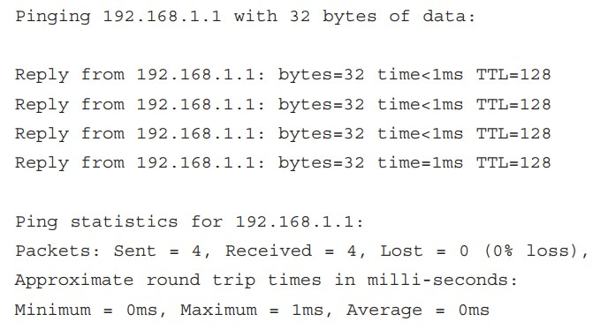

1. You can also ping **PC1**. Navigate to the **Command Prompt** for PC1 and enter the command **ping 192.168.1.3** at the prompt. The ping should be successful.
2. Close the **Command Prompt** when finished.

**Step 2:** Verify connectivity via the web browser.

1. Click **PC1**.
2. Click the **Desktop** tab.
3. Click the **Web Browser** to open the web browser application.
4. Enter **192.168.1.1** in the URL field and click **Go**. The Cisco Packet Tracer webpage should open.
5. Close the web browser when finished.
6. You can also use the web browser application on **PC0** to display the Cisco Packet Tracer webpage. Navigate to PC0. From the **Desktop** tab, open the **Web Browser** and enter **192.168.1.1** in the URL field.

## Part C.4: Basic Switch Configuration

You will perform some basic configuration on a switch using the **Config** and **CLI** tabs in Packet Tracer.

**Step 1:** The Config tab.

1. Click **Switch0**
2. Click the **Config** tab.

**Note:** The **Config** tab is not always available on physical networking equipment. Some simple devices only have config tabs. The config tab can be useful for basic learning of commands, especially for beginners.

The **Config** tab shows a list of components that can be configured on this device. We are not going to cover what these components are, as that is learned in a networking course, but we will show how to navigate and use the interface.

1. The **Global Settings** enables a user to change the name of a device that displays in the workspace. It also allows for changing the internal name shown at the command line prompt as well as buttons for saving, loading, exporting, and erasing configuration files.

Double-click in the **Hostname** dialog box to highlight the word Switch. Enter **Central** to replace Switch as the hostname. Packet Tracer will display the IOS commands necessary to accomplish the name change in the **Equivalent IOS Commands** box. The commands displayed should be as follows:

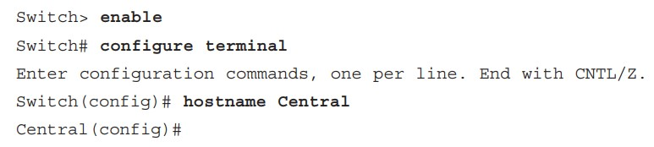

These would be the commands used from the command line interface, or CLI, to change the hostname. If you did not know how to do this from the CLI, the **Config** tab would show the necessary commands.

1. Click the **FastEthernet0/1** under the Interface heading to configure the FastEthernet0/1 interface.

In the **Equivalent IOS Commands**, the command **interface FastEthernet0/1** is displayed in the **Equivalent IOS Commands** box.

**Step 2:** The CLI tab.

1. Select the **CLI** tab to switch to the CLI interface. Notice that the same commands that were in the **Equivalent IOS Commands** box are listed in the CLI window.
2. At the prompt, enter **shutdown**.

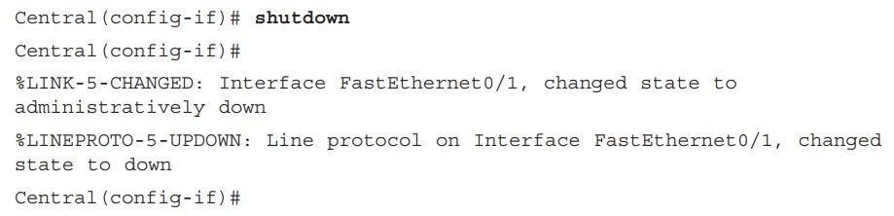

This command just shuts down the interface down from the command line.

1. Navigate to the Workspace. Notice that the link lights for the connection between PC0 and Switch0 are red. Because the interface on the switch was shut down, the connection is no longer active and shows red.
2. Save and close the activity, then exit Packet Tracer if desired.

# Lab 2 – Part D - Packet Tracer–Create a Simple Network

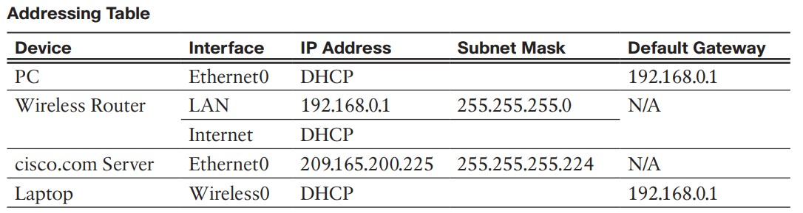

## Objectives

In this activity, you will build a simple network in Packet Tracer. ❖ **Part 1: Build a Simple Network**

❖ **Part 2: Configure the End Devices and Verify Connectivity**

## Instructions Part D.1: Build a Simple Network

In this part, you will build a simple network by deploying and connecting the network devices.

**Step 1:** Add network devices to the workspace.

In this step, you will add a PC, laptop, and a cable modem to the Logical Workspace.

Using the device selection box, add the devices to the workspace, add the following devices to the workspace. The category and sub-category associated with the device are listed below:

* **PC**: End Devices > End Devices > PC
* **Laptop:** End Devices > End Devices > Laptop
* **Cable Modem:** Network Devices > WAN Emulation > Cable Modem

**Step 2:** Change display names of the network devices.

1. To change the display names of the network devices, click the device icon on the Logical workspace.
2. Click the **Config** tab in the **Device Configuration Window**.
3. Enter the new name of the newly added device into the **Display Name** field according to the Addressing Table.

**Step 3:** Add the physical cabling between devices on the workspace.

Using the device selection box, add the physical cabling between devices on the workspace.

1. The PC will need a copper straight-through cable to connect to the wireless router. Select the copper straight-through cable in the device selection box and attach it to the **FastEthernet0** interface of the PC and the **GigabitEthernet 1** interface of the wireless router.

1. The wireless router will need a copper cross-over cable to connect to the cable modem. Select the copper cross-over cable in the device-selection box and attach it to the Internet interface of the wireless router and the **Port 1** interface of the cable modem.

1. The cable modem will need a Coaxial cable to connect to the Internet cloud. Select the **Coaxial cable** in the device-selection box and attach it to the **Port 0** interface of the cable modem and the **Coaxial 7** interface of the Internet cloud.

## Part D.2: Configure the End Devices and Verify Connectivity

**Step 1:** Configure the PC.

You will configure the PC for the wired network in this step.

1. Click the **PC**. In the **Desktop** tab, navigate to **IP Configuration** to verify that DHCP is enabled and the PC has received an IP address. Close the **IP Configuration** window when done.

1. In the **Desktop** tab, click **Command Prompt**.

1. Verify that the PC has received an IPv4 address by issuing the **ipconfig /all** command from the prompt. The PC should receive an IPv4 address in the 192.168.0.x range.

1. Test connectivity to the cisco.pka server from the PC. From the command prompt, issue the command **ping cisco.pka**. It may take a few seconds for the ping to return. Four replies should be received.

**Step 2:** Configure the laptop.

In this step, you will configure the laptop to access the wireless network.

1. Click **Laptop**, and select the **Physical** tab.

1. In the **Physical** tab, you will need to remove the Ethernet copper module and replace it with the Wireless WPC300N module.

* 1. Power off **Laptop** by clicking the power button on the side of the laptop.

* 1. Remove the currently installed Ethernet copper module by clicking on the module on the side of the laptop and dragging it to the **MODULES** pane on the left of the laptop window.

* 1. Install the Wireless WPC300N module by clicking it in the **MODULES** pane and dragging it to the empty module port on the side of the laptop.

* 1. Power on the **Laptop** by clicking the Laptop power button again.

1. With the wireless module installed, connect the laptop to the wireless network. Click the **Desktop** tab and select **PC Wireless**.

1. Select the **Connect** tab. The wireless network **HomeNetwork** should be visible in the list of wireless networks. Select the **HomeNetwork**. Click **Connect**.

1. Close **PC Wireless**. Select **Web Browser** in the **Desktop** tab.

1. In the web browser, navigate to **cisco.pka**.